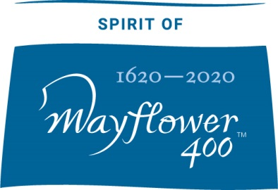

Mayflower 400 Community Sparks

In November 2019 Plymouth will join wider national and international partners for a year-long commemoration of the Mayflower’s journey from the UK to America. This global event explores the following values:

Freedom: the liberty of the individual to pursue their beliefs
Humanity: we do not discriminate, we are for everyone
Imagination: in the spirit of the Pilgrims we think big, we improvise and innovate
Future: we always look forward, building knowledge and legacy

Mayflower 400 Community Sparks supports grass-roots community, arts and cultural activity. Funding is available for projects that can be delivered by November 2020 and that will enable people living in Plymouth to take part in the Mayflower 400 commemoration. You can apply for a grant of up to £3000 and in exceptional circumstances £5000.

We welcome projects that explore our values and improve life for the people of Plymouth by including one of the following elements: fun, adventure, legacy or inclusion.

Who are you?

☐ Community group: Click here to enter text.
☐ Community members: Click here to enter text.
☐ An individual: Click here to enter text.

What project or activity would you like the money for and why?

Click here to enter text.

How is your project meeting one or more of the themes of Mayflower 400 and one or more of the elements of fun, adventure, legacy or inclusion?

Click here to enter text.

Who will benefit from this project or activity?

Click here to enter text.

How many people will benefit from this activity?

Click here to enter text.

Where will this activity take place?
Along with the venue/location, please name the ward the activity will take place in. For more information about wards check our ward map: https://www.plymouth.gov.uk/sites/default/files/CouncillorsWardMap.pdf
Click here to enter text.

How much money would you like and how are you going to spend it?

Click here to enter text.

If you have personal access costs please list them below (this may be relevant if you are disabled, deaf, experience learning difficulties etc)

Click here to enter text.

Contact details

Name:Click here to enter text.
Address:Click here to enter text.
Phone number/mobile:Click here to enter text.
Email address:Click here to enter text.

Mayflower 400 Community Sparks does not fund:

- Activities that take place outside Plymouth
- Retrospective grant aid for work already completed or which will have started before the application is considered
- Publicity campaigns
- Projects whose prime aim is to redistribute earned income from the proposal to other good causes including charitable appeals and organisations
- Commercially run projects
- NPOs (National Portfolio Organisations funded by Arts Council England) or national organisations
- Activities that are organised by companies or organisations as part of their normal remit or work activity

Mayflower 400 Community Sparks prioritises its funding to activities that are genuinely community based or generated, in order to support the widest number of communities of interest, identity or geography to take part in Mayflower 400.

- The deadline for this round of applications is 31st January 2019
- Please send your completed application form to: Fiona Evans, Vital Sparks, Plymouth Museums Galleries Archives, 37 Tavistock Place, Plymouth,
PL4 8AX or email to fiona.evans@plymouth.gov.uk
- For more information on Mayflower 400 visit Mayflower400uk.org, or follow us on twitter at twitter.com/mayflower400uk

