Migration
It is often assumed that Separatists on board the Mayflower sailed to New England to escape religious persecution. While they may have left England for Holland for reasons of religious persecution, they were not persecuted in Holland, not according to Bradford.
In his history Of Plymouth Plantation, William Bradford cites four reasons for leaving Leyden to travel to North America:
- the hardships of life in Holland; some would rather be in prison in England than suffer in Holland;
- the hard work and aging years of the group meant that they might scatter or ‘sink under their burdens’ very soon;
- their children were suffering under the hard work and economic hardships; the influence of a more liberal Dutch society also caused their parents’ concerns;
- they could spread the gospel in these ‘remote parts of the world’.
Only later in his history does he very briefly mention the gathering forces of Catholicism around Holland which might cause them to be persecuted.

Other migrations
Jamestown, the first successful settlement, was founded in 1607; other, earlier settlements included Roanoke and Popham. The Virginian Company (with competing London and Plymouth branches within it) helped finance these ventures.

. 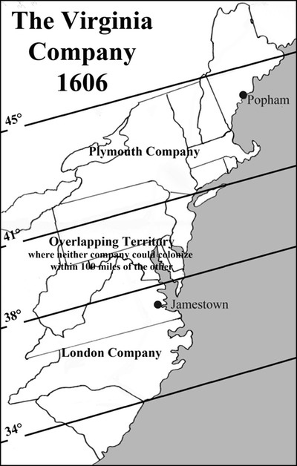
English migration to the New World lagged behind other European countries quite significantly. By the time the Mayflower reached North America, the French were settling the area to the north of New England, and the Spanish were colonising parts of Florida and New Mexico. The Spanish and Portuguese were already dominant in South America by the early part of the seventeenth century.
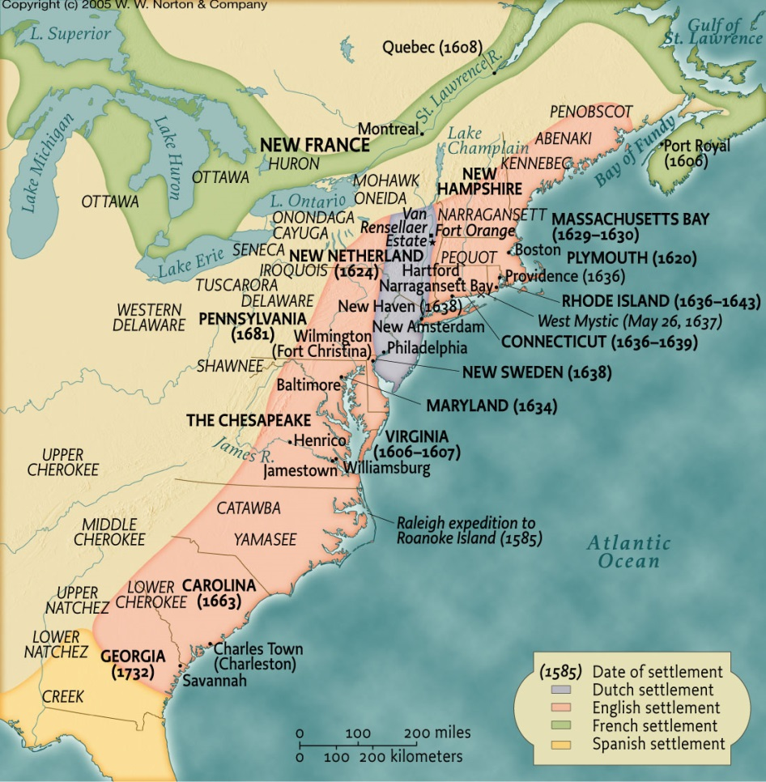
Map of colonial North America
English support for these ventures were largely about opportunities to develop stronger trading partnerships in North America and reaping the kinds of economic benefits that Spain and France appeared to be enjoying. To do this, the colonies needed to be populated, and it needed to be populated with workers.
To varying degrees, the colonies relied on a mixture of indentured servitude and then slavery to support the production and trade in tobacco and other goods across the Atlantic. In 1619, the Dutch brought the first slaves to Jamestown, but English slave traders were already establishing a foothold in the slave trade decades before. As early as the 1560s, Sir John Hawkins, from Plymouth, traded hundreds of African slaves to plantations in the West Indies.
Migration to the North American colonies in the early seventeenth century was motivated by a mixture of religious beliefs, particularly those involved in the Puritan migrations of the 1630s, economic determinants, and imperial design.
Further reading:
Alison Games, Migration and the Origins of the English Atlantic World (Harvard UP, 2001)
Willem Klooster and Alfred Padula (eds) The Atlantic World: Essays on Slavery, Migration and Imagination (Pearson, 2005)
David Armitage and Michael J. Braddick (eds) The British Atlantic World, 1500-1800 (Palgrave, 2009)
David Cressy, Coming Over: Migration and Communication Between England and New England in the Seventeenth Century (Cambridge UP, 1997)
Richard Middleton and Anne Lombard, Colonial America: A History to 1763. 4th Edition (Wiley-Blackwell, 2011)

