‘Contact Zone’
The term ‘contact zone’ is used by Mary Louise Pratt to identify the spaces in which two or more cultures, with competing worldviews and uneven power relationships, meet and interact. (See Imperial Eyes (1992)) In colonial New England, interactions between indigenous people and settlers are documented in all kinds of ways and in different kinds of texts.
Communication: written and spoken words
By and large, Native peoples of North America developed their societies, histories, religious practices, diplomatic agreements, medicinal practices etc. on the basis of an oral tradition. That’s to say that they did not commit their cultures and histories to a written record in the ways the Europeans did. By contrast, Puritans relied on the Bible, normally very literal readings of this written text, to help them define and codify their religious and civil laws. Written texts, including books, signed treaties and trade agreements, as well as key religious texts, were sources of knowledge and social order for many settlers of colonial New England. The Plymouth colony men signed the written text of the ‘Mayflower Compact’ because they came from a tradition that prioritised the written contract over the spoken word.
For many Europeans of this period and after, the lack of a written language was considered to be a sign of Native American primitivism. This assessment, however, has long since been abandoned, and the intricate and effective nature of inter-tribal communication, trading and diplomatic relationships, is now recognised. (see Matt Cohen, The Networked Wilderness (2010)) The survival of wampum belts, which served to record significant events or diplomatic relationships, provide evidence of a different kind of Native literacy and communication. In the area that became New England, wampum belts were made from shells local to the area; the beads, or wampum, also served as a form of currency.
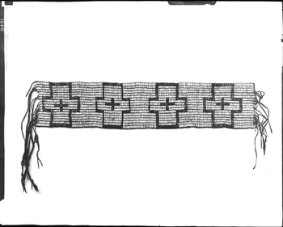
(The National Museum of the American Indian, as well as the British Museum, each has wampum belts in their collections.)
This was a world that colonial settlers engaged with: they traded with local people and they also established diplomatic arrangements with local leaders. In this contact zone, all parties would have expected and respected these trading and diplomatic arrangements. Therefore, when William Bradford writes about the diplomatic treaty he established with Massasoit, we should understand that this treaty was beneficial to both sides, and that inter-tribal diplomatic agreements pre-existed the arrival of English settlers in this region. Peace was in all of their interests: the colonial settlers were out-numbered and ill-prepared, and Massasoit’s tribe were vulnerable to their neighbours, the Narragansett.

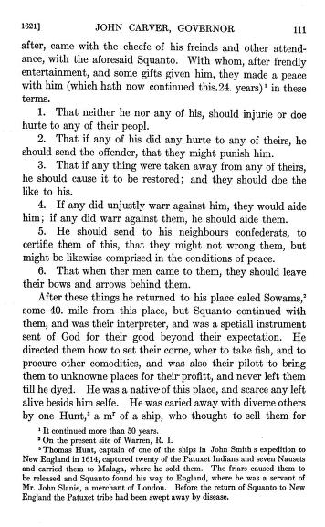
(See, Of Plymouth Plantation)

This is not to say that the two parties saw each other as equals; time and again, texts from colonial settlers betray their own sense of superiority. While William Bradford and Edward Winslow may be on record as having treated the Wampanoag with a relatively reasonable amount of respect and care, it is also true that they referred to their Native neighbours as primitive heathens, at best, and at worst, devils or savages. One can only speculate what Massasoit or Squanto really thought of the settlers’ desires to build fortifications, English-style houses, their clothes, and their initial ignorance about local husbandry.

Literacy and Religion
The religious conversion of Native Americans to Christianity was one of the reasons Bradford gave for settling in New England. To this extent, he largely failed. The Puritan mission in New England didn’t really begin until the 1640s when the Massachusetts Bay colony began to establish its programme of education and conversion, largely under the leadership of Rev. John Eliot. In the years of colonisation that followed, a written trace of the Massachusetts dialect of the Algonquian language was created and a language that had previously only been spoken was now written down. The Bible was published in Algonquian in several iterations as well as other religious texts and handbooks written by Puritan divines. (see Gray, John Eliot and the Praying Indians of Massachusetts Bay, (2013))
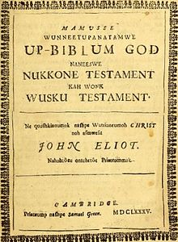

The arrival of literacy and Christianity had a huge impact on Native cultures in the region, often serving to erase oral traditions and Native spirituality. For many, this is considered to be a form of cultural genocide. Some Native communities chose to follow Christian traditions, while retaining their Native identities.

Ownership: guns and the land
On arrival, the colonial settlers in Plymouth were vulnerable and part of their defence was to maintain control over firearms: Bradford comments on the effectiveness of shooting off firearms in the very early stages of his arrival, to scare off inquisitive indigenous people. His anxieties about sharing firearms with Native people are explored when he remembers Thomas Morton’s decision to share firearms with his Native neighbours. This is one of many things that Bradford disliked about Morton: he also objected to his use, or abuse, of alcohol, his non-observance of the Sabbath, as well as his so-called pagan festivities around the Maypole. Morton is portrayed as something of a villain in Bradford’s work, upsetting the harmony of the colony; as might be expected, Morton tells the story very differently (see New English Canaan).
Ownership of weapons came under scrutiny, and the Plymouth Colony Records make clear that selling guns to Natives was a serious criminal offence. Natives who were already armed were understandably reluctant to give up their new weapons. The imbalance of power which firearms presented in this colonial contact zone bred resentment as the decades wore on. The increased incursion into Native land also became a point of tension. While Massasoit had made space for the first settlers, as numbers grew through the 1630s in particular and demands on the land increased, Native Americans were gradually removed from their land, either through land sale agreements (which were often dubious) or through conflict and war.
The Pequot War and King Philip’s War were two of the most defining wars of seventeenth century colonial New England. The Pequot War was promoted by tension arising from the arrival of many, many more Puritan settlers in the 1630s. King Philip’s War of 1675, again, was promoted by the ways in which Native American land and culture were becoming increasingly eroded. Following the Pequot War, Bradford reveals that Native male children were sent to Bermuda (sent into slavery) and the women and children were set to work in New England towns. (see, letter from Winthrop, 1637) Following King Philip’s War in 1675, many hundreds of Native captives were sold into slavery or died of disease when they were removed to Deer Island. There were many casualties on both sides in each of these wars. These conflicts mark the beginning of centuries of removal and relocation of Native tribes across America, as well as centuries of resistance to colonial dominance.

Further reading:
Karen Ordal Kupperman, Indians and English: Facing Off in Early America (Ithaca, 2000)
Phillip H. Round, By Nature and By Custom Cursed: Transatlantic Civil Discourse and New England Cultural Production, 1620-1660 (UPNE, 1999)
Jill Lepore, The Name of War: King Philip’s War and the Origins of American Identity (Vintage books, 1999)

